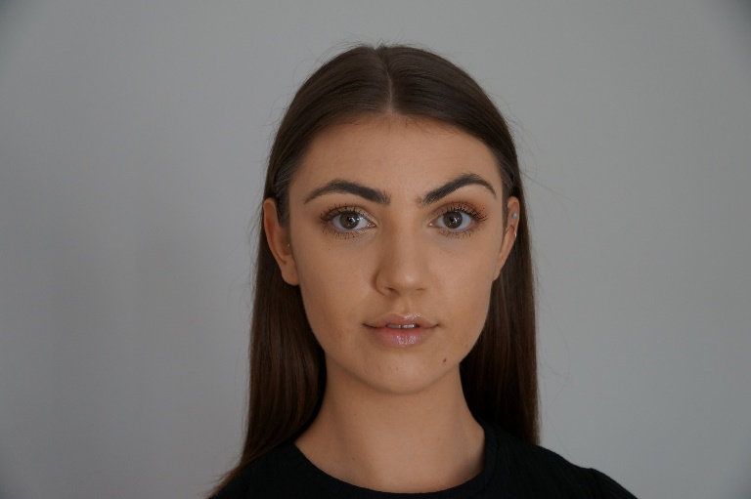

**Olivia Thorn**

Height: 5’7” Dress size: 8

Ethnicity: White Hair: Brunette

Eyes: Hazel Playing age: 16-25

**Professional**

*The King And I*, Kings children, New Victoria Theatre, Woking, Paul Kerryson, 2012

Matthew Bourne’s *Cinderella* Curtain Raiser, Cinderella, Mayflower Theatre, Southampton, Daisy May Kemp and Michela Meazza, 2018

*Beaujolais Day*, Burlesque and Cancan dancer, Grand Café, Southampton, Sarah Mepham, 2019

**Roles While Training**

(Stage)

*CATS*, Bombalurina, Solent University, Annie Sanger-Davies

*Waitress* Adaptation, Becky, Solent University, Louise Leigh

*WORKING,* Maggie Holmes, Solent University, Michael Goron

*Cabaret* Adaptation*,* Ensemble/Two Ladies, Solent University, Michael Goron

*‘I Told My Mum I Was Going on an R.E Trip’*, Tanaya, Solent University, Maddie Wilcox

(Film)

*Femme Fatale*, Detective Hana Johnson, Solent University, Jack Colledge

**Training**

Solent University- Musical Theatre BA(Hons), Undergraduate (2017- Present)

**SKILLS**

Dance: Gold Jazz and Inter Foundation Modern with ISTD Examination Board

Singing: Alto (F3-F5), Estill Vocal Training

Accents and dialects: RP, London/South East, General American

Languages: (* = Native/Fluent): English*

Sports: cycling, swimming

Guildford, Surrey, GU2 9GT

[thornolivia99@outlook.com](mailto:thornolivia99@outlook.com)

07538606644